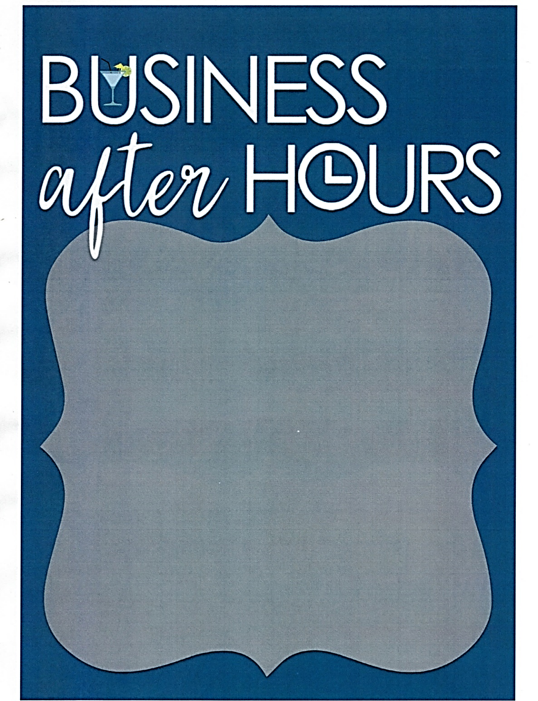

OPEN TO ALL CHAMBER MEMBERS!
Join us for:

Socializing
Mocktails & Dessert Bar
Tuesday
April 19th, 2022
4:30 - 6:00 pm
424 South Minnesota Ave, Saint Peter

